# 16-720 Computer Vision Spring 2016

# Azarakhsh Keipour (akeipour@andrew) Assignment 4

## Q 2.1 8-Point Algorithm

The calculated fundamental matrix F is:

-0.0000 0.0003 -6.3885

0.0008 -0.0000 -0.0743

6.1527 -0.0402 24.5403

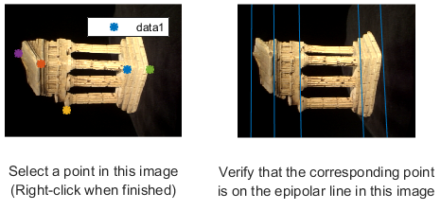

Figure 1. The result of finding correspondences using 8-point algorithm for finding the fundamental matrix.